
The MATRIX
User Guide

Features
- Operation
- Key Pad commands
- Serial port operation
- Serial port commands
- Controller connections
- Switching matrix connections
- Configuration
- Example commands

Appendix
- Switching Matrix - TDA8540 data sheet
- I/O ports - PCF8574 data sheet

Features

Signal switching matrix
Minimum size Plane 4 x 4
Maximum size Plane 56 x 56 (requires extension board)
Maximum number of Planes 10
Maximum number of Outputs 186
Switching impedance from 75 to 1000 Ohms
Switching is AC coupled with negative peak referenced to an O/P pedestal of 0.7V
For further details refer to TDA8540 data sheet attached.

Input Output channels
Single 8 bit channel, expandable to 64 bits (8 channels) on extension board
Output levels Low 25mA current sink @ Vol = +1V (suitable for direct LED drive)
High –1mA pull-up for 5uS, then -300uA @ Voh = +5V
For further details refer to PCF8574 data sheet attached.

Controller
2 Line LCD display and Hex key pad for local control.
Serial link: 3 wire, 19200 Baud using XON/XOFF flow control for remote control.

Single +12 volt supply. Current demand is 100mA for the controller + 500mA per 16x16 Video board + 300mA per 16x16 Audio board.

Control functions
10 Memories
Power up restore
Clear and Set individual cross-points
Clear and Set entire Planes
Clear and Set grouped Planes
Clear and Set individual IO control lines
Clear and Set entire IO channels

Operation

From power up the following display will appear for 4 seconds if there are no faults or problems with the MATRIX;
T | h | e |  | M | A | T | R | I | X |  | v | 1 | . | 0 | 0
0 | 1 | 0 | F | 0 | 8 | 0 | 1 | 0 | 2 | 1 | 0 | 0 | 0
The numbers in blue will vary according to the size of the switching matrix and number of Input Output (IO) Channels fitted. After 4 seconds a command prompt will be displayed, inviting you to enter a command;
O | K | >

In entering the various commands the following abbreviations and symbols will be used;

F Starts or restarts a command sequence.
E Completes an input sequence, executes command.

β Bit number within an IO channel,  to 7 allowed, single digit.
c Channel number for IO,  to 9 allowed, single digit.
m Memory,  to 9 allowed, single digit.
p Plane,  to 9 allowed, single digit.
r Restoration of power option,  to 9, C or D allowed, single character.
ii Two digit Input number,  to 99 allowed.
oo Two digit Output number,  to 99 allowed.

Any command that cannot be recognised, or that falls outside the range of the current configuration will cause the following response to appear;
O | K | > | F | F | E
C | a | n | ‘ | t |  | d | o |  | t | h | a | t | ! | !

All command sequences from the key pad start with the letter F (F for First), if you spot an error whilst entering a command then the command can be restarted by entering another F.

The end of a command sequence is always signalled by the letter E (E for End). This is needed as commands vary in length.

In outline the MATRIX program maintains a list of “new settings” indicating which Inputs are to be connected to which Outputs on each Plane and will at the end of certain commands, or will when instructed to, copy these settings to the switching matrix itself. This permits you to build up a set of connections, which can be implemented all at the same time (well within a few milliseconds), rather than at the speed at which you can enter commands. Without this ability then you would end up with say the video connection be made first, followed a few seconds later by the right hand audio channel and the left hand channel last of all several seconds later!

The IO channels are primarily pull down outputs, and will only source a small continuous current when in the High state. They can be used to drive LEDs directly, in which case the Anode of the LED should be connected to the +5V line available on the edge of the controller board, the outputs can sink up to 25mA.
If relays are to be operated directly then they to should be supplied from the controllers +5V line and have transient back EMF diodes across the coils. Do not operate the relays directly from external supply rails greater than 5 volts as otherwise the internal chip protection diodes will cause the external supply rail to be applied to the controllers +5 volt line.

Restore a memory setting
Entering; F m E Where m is a number between  and 9, this will restore the memory numbered m to the new settings and action the settings without delay. Below shows the result of restoring memory 0.
O | K | > | F |  | E

O | K | >
M |  | , |  | R | e | s | t | o | r | e | d

Save settings to memory
Entering; F m 2 E Where m is a number between  and 9, this will save the new settings into the memory numbered m, the new settings do not have to have been actioned first. This allows the memories to be programmed without affecting the actual switch settings in use. Below shows the result of saving to memory .
O | K | > | F |  | 2 | E

O | K | >
M |  | , |  | S | a | v | e | d

Clear a Plane
Entering; F p  E Where p is a number between  and 9, this will clear all Outputs on the Plane numbered p in the new settings and action the settings without delay. Below shows the result of clearing Plane 1.
O | K | > | F | 1 |  | E

O | K | >
P | 1 | , |  | A | l | l |  | c | l | e | a | r | e | d

Set straight links
Entering; F p 1 E Where p is a number between  and 9, this will set all Outputs on the Plane numbered p to the corresponding Input in the new settings and action the settings without delay. Below shows the result of set straight links on Plane 1.
O | K | > | F | 1 | 1 | E

O | K | >
P | 1 | , |  | S | t | r | a | i | g | h | t |  | s | e | t

This command is useful if your physical Inputs and Outputs are arranged in the correct order so that linking Input  to Output , Input 1 to Output 1 etc is your most preferred setting.

Set Input to all Outputs
Entering; F p oo 1 E Where p is the Plane number between 0 and 9, this will set Input ii to all Outputs on the plane p. Below shows the result of set Input to all Outputs on Plane 0 for Input 3.
O | K | > | F |  |  | 3 | 1 | E

O | K | >
P |  | , |  | I |  | 3 |  | T | o |  | a | l | l
The following two commands will either work on the grouped planes or if no group has been specified then on Plane 0 alone.

Clear link in group
Entering; F oo  E Where oo is the Output number to be cleared on all Planes that form the group. Below are the result of clearing Output 2, where the group option has been set.
O | K | > | F |  | 2 |  | E

O | K | >
P | G | , |  | O |  | 2 |  | C | l | e | a | r | e | d

Set link in group
Entering; F ii oo 1 E Where ii is the Input number and oo is the Output number to be set on all Planes that form the group. Below shows the result of setting Input 1 to Output 2, where the group option has been set.
O | K | > | F |  | 1 |  | 2 | 1 | E

O | K | >
P | G | , |  | I |  | 1 | - | O |  | 2 |  | S | e | t

The following commands do not take affect immediately; they allow new settings to be built up and then actioned as required.

Action settings now
Entering; F E This command forces the new settings to be copied to the switching matrix, thus enabling the settings. Below shows the results.
O | K | > | F | E

O | K | >
C | h | a | n | g | e | s |  | a | c | t | i | o | n | e | d

Clear Output on Plane
Entering; F p oo  E Where p is the Plane number on which Output oo is to be cleared, this changes the new settings only. Below shows the results for clearing Output 3 on Plane 1.
O | K | > | F | 1 |  | 3 |  | E

O | K | >
P | 1 | , |  | O |  | 3 |  | C | l | e | a | r | i | n | g

Set Input to Output on Plane
Entering; F p ii oo 1 E Where p is the Plane number on which Input ii will be linked to Output oo, this changes the new settings only. Below are the results for setting Input 2 to Output 1 on Plane 3.
O | K | > | F | 3 |  | 2 |  | 1 | E

O | K | >
P | 3 | , |  | I |  | 2 | - | O |  | 1 |  | L | i | n | k
The following commands enable control of the IO channels, they act immediately.

Display channel
Entering; F c B E Where c is the channel number to be displayed. The state of all bits in the channel will be displayed as actually read from the pins of the chip. Below shows the result of requesting channel 0.
O | K | > | F |  | B | E

O | K | >
C | h |  |  |  |  | 7 |  | 1 | 1 | 1 |  |  | 1 | 1 | 1

Clear bit on channel
Entering; F c β  A E Where c is the channel number and β is the bit to be cleared. Below shows the result of clearing bit 2 of channel 0.
O | K | > | F |  | 2 |  | A | E

O | K | >
I | O |  | C | h |  |  | b | 2 |  | L | o | w

Set bit on channel
Entering; F c β 1 A E Where c is the channel number and β is the bit to be set. Below shows the result of setting bit 3 of channel 0.
O | K | > | F |  | 3 |  | A | E

O | K | >
I | O |  | C | h |  |  | b | 3 |  | H | i | g | h

The following two commands relate to configuration options, they act immediately.

Power restoration
Entering; F r 4 E Where r is the source of the settings to be restored when the MATRIX is powered up. If r is between  and 9 then the corresponding memory will be restored, if r is C then the previous current settings will be used, if r is D then no connections will be made, however the previous settings will still be available in the new settings. Below shows the previous settings being selected.
O | K | > | F | C | 4 | E

O | K | >
P | w | r | . |  | u | p |  | s | e | t |  | p | r | e | v

Reconfigure MATRIX
Entering; F 1 A E Causes the MATRIX to re-start and enter configuration mode. This can be used when IO channel configurations need to be changed or where grouping options need to be altered and no hardware change has occurred. Please note reconfiguring the matrix will wipe ALL previous settings and memories!! An option will appear to confirm reconfiguration before changes are entered.

Serial port operation

The serial port uses 3 wire operation and is compatible with either RS232 voltage levels (±12 volt) or serial ports using 0v / +5v / TTL level operation. The port is self configuring for these differing drive levels. The baud rate is fixed at 19200 Baud, 8 bit, no parity, 1 Stop bit and uses Xon / Xoff software flow control.

Serial operation fully supports the previous Key pad commands and hence can be driven from a dumb terminal or terminal emulation program. The only change in the command format is that the symbols ж should be used in place of F and the symbol # should be used in place of E. This change is in order to allow support for the full range of Hex codes 0-9/A-F when used from a computer.

The responses from the controller to the serial port do not the match the text messages on the LCD display, but are in a form more suited for being handled by a program.

Similarly the power on messages are different and at the present time the configuration routine is not supported from the serial port.

The following sections describe the power on sequence, the responses to the Key pad commands and then the remaining serial port only commands.

All serial port responses to commands consist of an ASCII sequence of the form “>NNxxxxxxxxxx#”
Where NN is a response number in hexadecimal format indicating the message type. This may then be followed by a string of hexadecimal numbers where appropriate as a parameter.

All key pad characters will be sent to the serial port, with the characters F and E translated to ж and # respectively

Power on sequence
During the initialisation process an XON (0x11) code will be sent to ensure that the flow control from a terminal or computer port is not blocked before any other characters are sent.
At the end of initialisation the sequence “>00VVRR#” will be sent where VV is the version number and RR the current release number.

It is recommended that whenever the above sequence is received, under program control, then a “Configuration dump” request is issued by the program so that the internal states of the controller PIC program can be collected and used to synchronise the remote program to a similar state.

Key pad commands

All entries made from the key pad will be sent to the serial port with the translation of F to ж and E to #, serial port commands should use ж and # at all times.

Serial port commands

The response codes sent to the serial port are as follows;

Command | LCD Response | Serial Response | Notes
On power up | “The MATRIX vv.rr” | >00vvrr# | vv=Version,  rr=Release
ж# | “Changes actioned” | >10#
жm# | “Mn, Restored ” | >12#
жp# | “Pn, All cleared ” | >14#
жp1# | “Pn, Straight set” | >16#
жm2# | “Mm, Saved ” | >18#
жoo# | “Pn, Onn Cleared ” | >1A#
жpoo# | “Pn, Onn Clearing” | >20#
жpii1# | “Pn, Inn To all” | >1D#
жiioo1# | “Pn, Inn-Onn Set ” | >1C#
жpiioo# | “Pn, Onn Clearing” | >20#
жpiioo1# | “Pn, nn-Onn Link” | >22#
ж3# | “Config sent” | >04vvrree….cc……….# | ee 128 hex pairs representing PIC flash config settings ¹  cc CMOS memory ²
жr4# | “Pwr. up Mn”  “Pwr. up set prev”  “Pwr. up set none” | >1E# | R=0-9  R=C  R=D
жcβA# | “IO Channel=n bn low” | >30#
жcβ1A# | “IO Channel=n bn high” | >30#
жchhB# | “IO Channel set” | >34# | hh =Hex pair for byte
жcB# | “Chn 0~7 ????????” | >32hhhhhh..# | hh hex pairs for each channel implemented.
Invalid command | “Can’t do that!!” | >02#
Notes:
¹ The EEPROM memory allocations are as defined below
Byte 0 - 0xFF = No configuration, 0x01= Existing configuration, 0x00 reconfiguration requested.
Byte 1 - b0=1=Keypad required
- b1=1=LCD display required
- b2=1=2 line LCD display required
- b3=1=Serial port required
Byte 2 - External CMOS EEPROM, count of 24C0x 256Byte blocks at address 1010xxxr
Byte 3 - Extended I/O, count of PCF8574(A) devices at address 0100xxxr (0111xxxr)
Byte 4 - I2C Bus Multiplexor, count of PCA9544 devices at address 1110xxxr
Byte 5 - Count of switches, total of devices on all busses at address 1001xxxr
Byte 6 - Summation of outputs.
Byte 7 - Reserved.
Byte 8 - Count of Planes
Byte 9 - Group flag bits, b0=Plane 0 … b7=Plane7
Byte A - Group flag bits, b0=Plane 8, b1=Plane 9, b7 =1= no grouping flag
Byte B - E Reserved
Byte F - Restore settings byte
Byte 10 - Inputs, Plane 0 ÷ 4, count of vertical switches
Byte 11 - Outputs, Plane 0 ÷ 4, count of horizontal switches

Byte 12 - Number of first switch in Plane 0
Byte 13 - Low order CMOS address to current settings for Plane 0
Byte 14 - 17 Plane 1 as above
Byte 18 - 37 Planes 2 to Plane 9 as above
Bytes 38 - 3F Reserved
Bytes 40 - 5F Reserved
Bytes 60 – 6F 16 * IO channel write values
Bytes 70 - 7F 16 * IO Channel I/O mask bytes 1 = Input, 0 = Output

² The external CMOS EEPROM memory is used to retain the new settings and also the ten memories. The allocation is simply the output number starting from Plane 0 and the value is the input number + 1, the zero state is used to indicate that the output has no input switched to it.
Thus if Plane 0 has 8 outputs and Plane 1 has 4 outputs then the allocations are;
bytes 0 to 7 Plane 0, 8 to 11 Plane 1, will be used to store the new settings,
bytes 12 to 23 will be used to store memory 0,
bytes 24 to 35 for memory 1,
up to bytes 120 to 131 for memory 9.

Controller connections

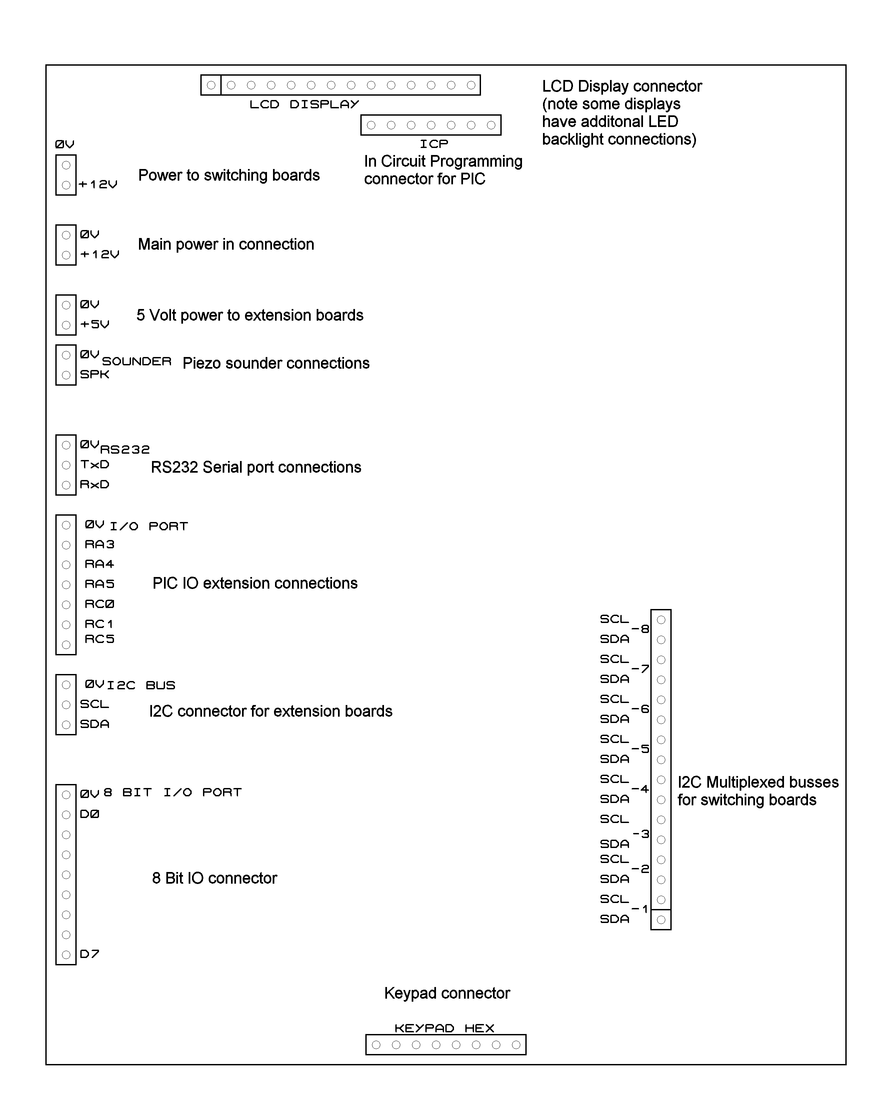

Switching matrix connections
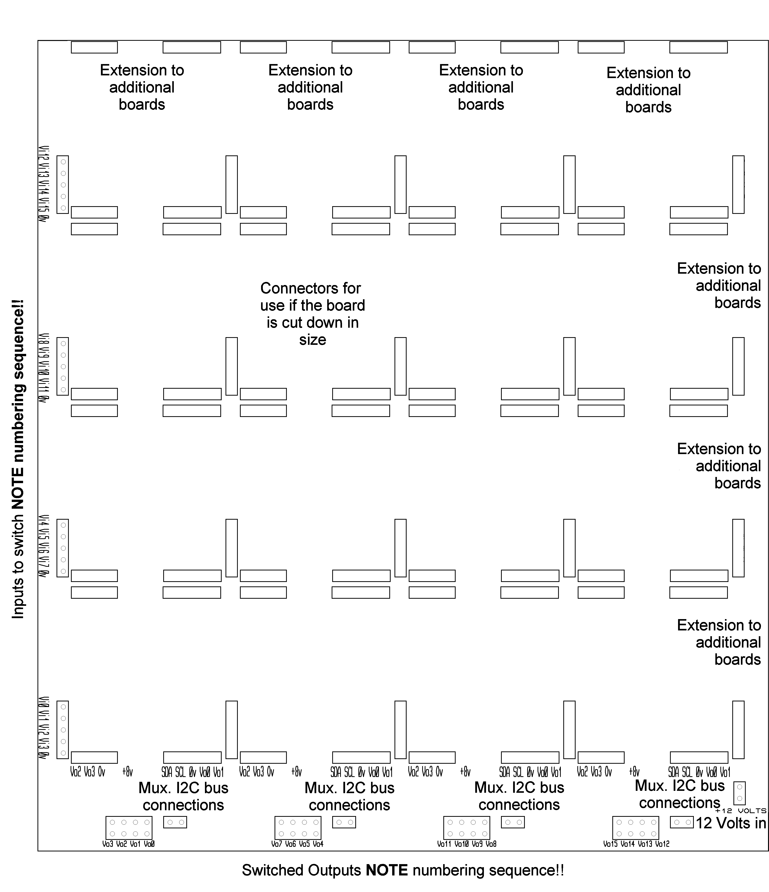
NOTES;
The multiplexed (Mux.) I2C buses are connected such that there are 7 4x4 switching blocks per bus thus it will necessary to link the buses in columns – see the construction sheets for details.

The Input and Output connections are NOT sequential, please note the numbering on the boards CARFULLY!!

Configuration

The software provided in the PIC carries out a check during power up of what devices are connected to its I2C bus. It uses this data along with some information that you will key in shortly to configure the switches and other hardware into a working system. At the end of the process it stores all this information and during subsequent power ups it checks the data to make sure that nothing has changed since it was last used. In this way if you add additional hardware the software can ask you to re-configure it, also should a fault develop then there will be a warning and information on what has changed! ! Note if you haven’t made any changes and you are asked “Reconfigure ??” then your system has developed a fault! Choose NO, and revert to the previous configuration and begin testing!

T | h | e |  | M | A | T | R | I | X |  | v | 1 | . | 0 | 0
F | F | 0 | F | 0 | 8 | 0 | 1 | 0 | 2 | 0 | 7 | 1 | F
FF=Never configured Changes indicator
01=Previously configured
00=Requested reconfigure
Requires Keypad Count of TDA8540
Serial port & LCD display chips fitted
Count of CMOS memory Count of PCA9544
in 256Byte blocks chips fitted
Count of PCF8574(A)
chips fitted

The first time the MATRIX is been powered up then 4 seconds after the above has been displayed then the following question will be posed;
R | e | c | o | n | f | i | g | u | r | e | ? | ?
 | F | = | Y | E | s |  |  | E | = | N | o
If a hardware change has occurred (or a fault developed) then a warning message will be displayed requesting that you press the “F” key to acknowledge the change first.

To reconfigure respond with an F, if the reconfiguration has been manually requested with a reconfigure command then by responding with a E will restore the previous settings.
All acceptable answers will result in a rising double beep, unacceptable answers a falling double beep.
Next question is;
P | l | a | n | e | = | 0 |  | E | n | t | e | r |  | #
o | f |  | I | P | ‘ | s | = | ? | ?
You are being asked to enter the number of Inputs that Plane 0 has, this should always be entered as a two digit number i.e. ‘08’ or ‘16’. It will also need to be a multiple of 4, otherwise a beep and the question will re-appear. If you make an error and spot it then press # and any other digit.
P | l | a | n | e | = | 0 |  | E | n | t | e | r |  | #
o | f |  | O | P | ‘ | s | = | ? | ?
OK, you guessed it now the number of OP’s for Plane 0, again a two digit answer.

These two questions will now repeat, but for Plane 1, then Plane 2 etc until all the 4x4 switch elements have been accounted for. If you make a mistake with one of the numbers and didn’t spot it then either you will be told;
T | o | o |  | B | i | g |  | ! | !
And after a few seconds you will be sent back to Plane 0 to start again.
Or if you get asked the question for more Planes than you expected, then somewhere along the line you answered with too small a number and hence it believes there is yet another Plane to be defined. In this case just put a large number in ‘88’ for example and then you will be sent back to Plane 0 to start again.
When you have all the Plane information in correctly, then you will be greeted with a set of bleeps to signify that the planes are completed.

At this point there is an option offered if there has been more than a single Plane defined, this is to allow the creation of a ganged group of Planes that, using certain commands, will operate together for more information on grouping refer to the MATRIX User Guide;
G | r | o | u | p |  | P | l | a | n | e | s |  | ?
 | F | = | Y | e | s |  |  | E | = | N | o
If you wish to take this option then answer F otherwise E, in which case skip the following section and continue with the Input and Output lines.

G | r | o | u | p |  | P | l | a | n | e | = | 0
 | F | = | Y | e | s |  |  | E | = | N | o
You can now answer Yes or No to each Plane that has been previously defined, if you answer Yes then that Plane will be added to the grouped planes. Answering No will leave that Plane out of the group.
When the last Plane number has been dealt with then again a set of bleeps will be sounded to indicate the end of this section.

So on to the Input and Output lines, with the next stage;
I | O |  | C | h | a | n | n | e | l | = | 0 |  | b | 0
t | y | p | e |  | 1 | = | I | P |  | 0 | = | O | P |  | ?
Due to the size of the display the question is a bit terse, but you are being asked to define the 8 IO lines as either Inputs (1) or Outputs (0) for the Channel 0 (this is the PCF8574(A) chip on the controller board itself, additional chips up to a max. of seven can be fitted on an extension board to give 64 control lines). If you don’t intend to use the control lines then make them Inputs by typing in a ‘1’. The question will then repeat for bit 1 (b1) and so on up to bit 7, eight lines in all.

Once completed then yet another set of bleeps to signify completion and the message;
S | a | v | i | n | g |  | d | a | t | a
0 | 7
With a fairly rapid count is displayed whilst the information is stored in the flash memory within the PIC chip.

After the data is safely stored then the board will restart, this time after the initial checks have been made you should be given the command prompt;
O | K | >

Example commands

This section explores some of the likely commands you will want to use from the keyboard, it does not discuss using commands from a computer as it is expected that any software will have its own instructions. However it is acceptable to generate the commands via a serial link replacing the “F” with a “∗” and “E” with a “#” this is required as from the serial link you can send the full range of hexadecimal codes which include the letters F and E. If you are using a version of Windows then the HyperTerminal program included under Accessories | Communications can be used to send the commands.

First a word about the way the commands are stored and acted upon in the Matrix. As each Output can only have a single Input connected to it at a time this is the way that the connections are stored internally, as a series of input numbers for all the outputs. Whilst it may seem more obvious to remember which outputs are connected to an input this poses problems as all the outputs on a given plane could be connected to the same input. After using the Matrix for a while from the keypad you may also find that it is easier to remember the patterns that have been connected in terms of what is connected to each output. Now when a command is first entered into the Matrix, the changes are first stored in a buffer area before being sent to the switches themselves. This is done so that a number of changes can be entered before being acted on in one quick burst. Some commands will only build up the changes without making the switches change until you are ready to action them, others will make the requested changes and then initiate the actions automatically.

Second you will have noticed that the numbering scheme within the Matrix starts at ZERO not at ONE, some people do not find this natural! There are some very good reasons for starting at 0, the most significant is that the Matrix can happily cope with 100 inputs or outputs, starting from 0 means that only TWO digits (00-99) rather than THREE (001-100) need to be entered to for each Input or Output to be switched!

Now connect a number of Video and Audio sources to the Inputs of the Matrix, and likewise a number of monitors to the Outputs use the inputs and outputs starting from 00 and working upwards. The examples will use only the 4 lower numbers so that you can try them yourselves no matter what size or shape your version is. These examples assume that Plane 0 is used for Video and that Planes 1 & 2 carry the Audio signals, no grouping has been assumed to start with – these may not match your setup. At the end of each section there is a summary list of commands used.

During the construction phase you will have found that checking all the stages switch correctly can best be checked by using the “Set Input to All Outputs” so this might be a good place to start explaining the commands!

Power up the Matrix and wait for the “OK>” to appear. The first example will connect Input 00 to all the Outputs on Plane 0, the command takes the form F p ii 1E = F 0 00 1E, this command will switch immediately it is completed and displays “P0, I00 to All” as its response on the second line of the display. You should see all the monitors viewing what ever is connected to input 0. Try using the command now to view Input 01 on all the Outputs, the command should be “F0011E”. Now try connecting the audio planes as well using the command “F1011E” and “F2011E”.

A common command to use, especially if you have arranged for your most common arrangement of connections to follow this pattern, is to connect Input 00 to Output 00, Input 01 to Output 01, etc up to the limits of your plane(s). This is termed “Straight Links” the format of the command is F p 1E = F 0 1E to connect all Inputs to there corresponding Outputs on Plane 0. You should see displayed “P0, Straight set” again this command will set the switches immediately, using F11E and F21E will setup the audio planes as well.

This combination above of all three planes might be your preferred settings when you first turn on your Matrix each time. In which case lets first store these settings in memory 0 and then setup the Matrix to use memory 0 as its default settings on power up. So to store these settings the format is F m 2E = F 0 2E the display will read “M0, saved”, lets check that this has happened by first clearing all the links and then restoring them from memory 0, to clear the links we can use the “Clear a Plane” command F p 0E = F 0 0E and F 10E also F 20E all the links will have been cleared now, so lets restore memory 0 to confirm that it has the settings we want. To restore the command format is F m E = F 0 E, and we should now have back the links on all three planes for a straight setup. Now to arrange for the Power up restore to use memory 0 as its source the command format is F r 4E = F 0 4E the display will show “Pwr. Up set M0”. As a check turn off the power and back on again, only the normal prompt will appear but the links should be set up as expected. You can actually use any of the memories for the power up settings and there are a couple of others as well if you want to use the “Current” i.e. prior to the power off settings use “C” for the value r. Another possibility is to Delete all the settings to use this replace the r with a “D”, you should note that the previous setting is still available to you stored in the buffer area but just not sent to the switches themselves when you use this option.

Now lets use another couple of commands to change from the default settings, first lets disconnect the Audio on output 2 and then connect Output 3 on all planes to Input 0 and action the changes all together, first lets switch off the two audio planes on output 2 using the individual commands to Clear the Output the format is F p oo 0E = F 1 02 0E and then F2020E to switch off both channels, now lets connect Output 3 on all three planes to Input 0 this uses the Set command with the format F p ii oo 1E = F 0 00 03 1E and F100031E also F200031E however at present no actual switching has taken place so we need to action all 5 changes together with the “Action now” command “FE”.
Summary

F0001E “P0, I00 to All” Connects input 00 to all outputs on plane 0.
F0011E “P0, I01 to All” Connects input 01 to all outputs on plane 0.
F1011E “P1, I01 to All” Connects input 01 to all outputs on plane 1.
F2011E “P2, I01 to All” Connects input 01 to all outputs on plane 2.

F01E “P0, Straight set” Connects inputs to outputs straight on plane 0.
F11E “P1, Straight set” Connects inputs to outputs straight on plane 1.
F21E “P2, Straight set” Connects inputs to outputs straight on plane 2.

F02E “M0, saved” Save settings to memory 0.

F00E “P0, All cleared” Clears plane 0 of all connections.
F10E “P1, All cleared” Clears plane 1 of all connections.
F20E “P2, All cleared” Clears plane 2 of all connections.

F0B “M0, Restored” Restore memory 0.

F04B “Pwr. Up set M0” Power up restore uses memory 0.
Turn off the power, and then turn it back on
“OK>” Settings are restored from memory 0.

F1020E “P1, O02 clearing” Clear connection to Output 02 on plane 1.
F2020E “P2, O02 clearing” Clear connection to Output 02 on plane 2.
F000031E “P0, I00-O03 link” Set connection from Input 00 to Output 03 on plane 0.
F100031E “P1, I00-O03 link” Set connection from Input 00 to Output 03 on plane 1.
F200031E “P2, I00-O03 link” Set connection from Input 00 to Output 03 on plane 2.
FE “Changes actioned” Enable all 5 changes above.

Group commands

Frequently the Matrix will be used in situations where it would be normal to have all, or some, of the planes switch together where for instance you want the sound and video sources to all follow each other. This is where the grouping facility comes in. During the configuration stage you can opt to group a number of planes together, you are not restricted to three, or consecutive planes just confirm which plans are to be grouped. If you want to try the effect of the commands issue a reconfigure command which is “F1FE” this will then take you back through the configuration phase where the group of planes can be setup. Do note however that a reconfiguration will wipe any stored memories. The examples will assume that planes 0, 1 and 2 have been grouped, and that plane 0 carries the video as before.

There are only two commands that use the grouping facility Set and Clear links. After a reconfiguration no links will be setup so issue the following set command the format is F ii oo 1E = F 00 03 1E the display will show “ PG, I00-O03 set” now use F 01021E the display will read “PG, I01-O02 set”, this time all three planes will have switched together so that now you do not have to setup the audio channels separately.

Lets now connect output 03 to input 02 the command F02031E will do this. Grouping does not preclude setting the audio channels independently, for instance the command F100021E followed by F200021E and then FE will allow the audio from input 00 to be routed to output 02 independent of the grouping facility. Finally lets clear all the links using the group clear command, the format is F oo 0E = F 00 0E which displays “PG, O00 cleared”, follow this with F010E, F020E and F030E and now all links on all planes will have been cleared.

SUMMARY

F1FE Matrix resets and enters reconfiguration mode.
During reconfiguration group planes 0, 1 and 2.

F00031E “PG, I00-O03 set” Sets links on planes 0,1 and 2 between input 00 and output 03.
F01021E “PG, I01-O02 set” Sets links on planes 0,1 and 2 between input 01 and output 03.

F02031E “PG, I02-O03 set” Sets links on planes 2,1,and 2 between input 02 and output 03.
F100021E “P1, I00-02 link” Sets a link on plane 1 between input 00 and output 02.
F200021E “P2, I00-02 link” Sets a link on plane 2 between input 00 and output 02.
FE “Changes actioned” Sets the above two links in place.
F000E “PG, O00 clearing” Clears links on planes 0,1 and 2 to output 00.
F010E “PG, O01 clearing” Clears links on planes 0,1 and 2 to output 01.
F020E “PG, O02 clearing” Clears links on planes 0,1 and 2 to output 02.
F030E “PG, O03 clearing” Clears links on planes 0,1 and 2 to output 03.

