
The MATRIX
Construction Guide

Overview
- Construction tools and tips for SMD
- Controller construction
- Switch board construction
- Configuring the MATRIX
- Testing the MATRIX

Appendix
- Surface Mount Technology (VK3EM)

Overview
Welcome to the MATRIX kit, these notes describe the construction of the boards.

The kit consists of a controller board and a number of switching boards. The controller board is identical for all kits but there are a number of possibilities relating to the number and types of signals to be switched for the switching boards, hence these instructions are divided into 3 sections relating to common aspects, the controller and the switch boards.

Both types of board use a mix of surface mounted devices (SMD) and wire ended components. If this is your first sizeable project using SMD then please read the SMD section carefully. Using SMD is not as difficult as might first seem, but there are a number of tips, tools and techniques that are worth using and practising to make life easier!

As with all kits please take the time now to check that you have identified all the parts, should there be any parts missing or damaged then please call the number below or use the Web to contact us.

Before you start any building, give consideration now, to how you intended to box the unit and make the connections to the outside world, the latter is quite important as there will quite likely be a large number of connections which will take up a sizeable amount of room. If you are happy using phono connections then a good choice is the 2x4 array available from Maplin for about £1.15 each. These decisions may also influence the way you choose to connect the display and keyboard, hence the warning at this point.

Power for the unit is at +12 volts and the current will depend on the number of switch boards in use. The controller alone takes 100mA, a 16 x16 video switch takes a peak current of about 500mA and an audio version takes about 300mA.

It is recommended that you start by building and testing the controller board first. Then progress on to building the matrix switching boards. Setting up the addressing and finally connecting the boards together, testing and configuring the whole system.

Finally the MATRIX is very flexible in terms of the size of the switching matrix it can handle however there are some limits so if you are thinking of constructing a very large design then please feel free to give me a call to discuss your requirements. The current controller boards will handle up to 56 4x4 switches which is adequate for 3 Planes of 16x16 and still have a further 8 4x4 switches to play with, or a single Plane of 28x28 with 7 remaining 4x4 switch blocks. Beyond this an additional extension board for a further 6 PCA9544 is required. This extension board will also handle a further 7 I/O chips to allow a total of 64 IO lines if required.

Construction tools and tips for SMD

These notes are not intended to be exhaustive, there are plenty of good ideas that can be put to use. If you have discovered / located some not mentioned here then by all means send me the details and where possible I will include them in these notes or on the website for the kit. A lot of the ideas here come from a search on Google with the keywords of; SOLDERING TIPS HINTS SMD OR SMT

I have also included a write up on SMT by VK3EM, which is an excellent review of the technology and how the parts can be used in development and small quantities.

Most people find the size and apparent density of connections on IC’s as the most daunting part, however provided you take care to use the right tools for the job then you will be surprised how easy it actually is. So what tools should you have available?

SOLDERING IRON
The soldering iron and the size of the bit is probably the single most critical factor. The best choice of soldering iron will be one that is temperature controlled, if you don’t have one then prices start at about £40 from most suppliers. After this the choice must be to use an iron of about 15 Watts, you don’t need much power as the bits you need to use are small and the legs and pads are even smaller!

SOLDERING IRON BITS
So what bits to use? For the IC’s I prefer a pointed conical tip with a long thin shaft, for other components then the smallest size of tip with about a 1mm working face. If you think you can justify it then Antex do a range of SMD bits, which cover all the standard sizes, in a range of packs. This makes a lot of sense as the availability of wire ended components is beginning to reduce and there price is starting to climb. It is likely that in the future more and more kits will HAVE to use SMD as the components will not be available in wire or DIL formats! One other thing, you will need to change bits frequently, don’t try to bodge the job by using the wrong size / shape it will take longer and more likely to do damage than the time it takes to change the bit.

SOLDER
Most people use 0.71mm dia. or 22swg reels of solder. This is NOT the ideal size as you will need less than a 1mm in length per joint and that is difficult to achieve! It is well worth (essential) getting a reel/length of the smallest size available which is 0.46mm or 26swg as the length is much more controllable; 1mm of 22swg = 2.5mm of 26swg in volume of solder. If you intend doing a lot of construction work with SMD then its worthwhile looking at getting a supply of both solder paste and also a flux pen as this helps both with holding the SMD in place and getting an excellent flow of solder. If you do use solder paste then make sure you don’t use to much paste on a pad, its is VERY surprising how little is required!

MAGNIFYING GLASS
Most people will need some assistance in this area for reading the value of devices and resistors and checking joints. Magnifications of about x3-4 are fine x6 can be used but you may find that the area in focus is getting a bit small unless the lens is quite big in size. A good, cheap source are car boot sales! But all the normal suppliers have devices in their tools section starting from about £3.

TWEEZERS
Some fine pointed tweezers are well worthwhile. I tend to use a pair with angled tips, and reverse action types (squeeze to release) when actually positioning devices. Scribers, dental picks and cocktail sticks (wooden) are also helpful for positioning and holding devices down whilst soldering.

TIPS & TRICKS
Work on a bench with a raised lip (or a large shallow tray) surrounding the entire area, then when a component slides off the board / pings out of the tweezers you stand a better chance of locating it!

Place and solder all SMD devices first, before placing any wire ended components, that way the PCB will lay flat on the work surface when soldering the SMD otherwise the board will rock and skate around when its resting on the ends of the wire ended components.

To position chips more easily use a couple of small balls of Blu-Tack at each end of the chip, then by pressing the Blu-Tack the exact position of the chip can be adjusted to align with the PCB tracks. Solder tack the corner pins and remove the Blu-Tack before soldering all the leads.

Use a Flux Pen to moisten an area, as the flux dries it will leave a sticky / tacky area which also helps to hold devices in position. The extra flux is also a good idea generally when soldering SMD.

I tend to place identical value SMD across the whole board, rather then completing a section of the board at a time. This means you are less likely to mix up components which are difficult to identify. Ceramic capacitors are the worst for this as they are not generally marked, other than in different shades of brown!

Tinning the soldering iron bit is vital, the bit should always be nice and shiny with a thin coating of solder. The best method of cleaning and tinning I have found is the Multicore Tip Tinner / Cleaner available from Farnell, it’s a small tin of solder, flux and abrasive which you scrap the tip of the bit on with really impressive results.

To remove the components from the strips, lift the clear plastic tape using the tip of a craft knife and peel back, only remove a few components at a time!!

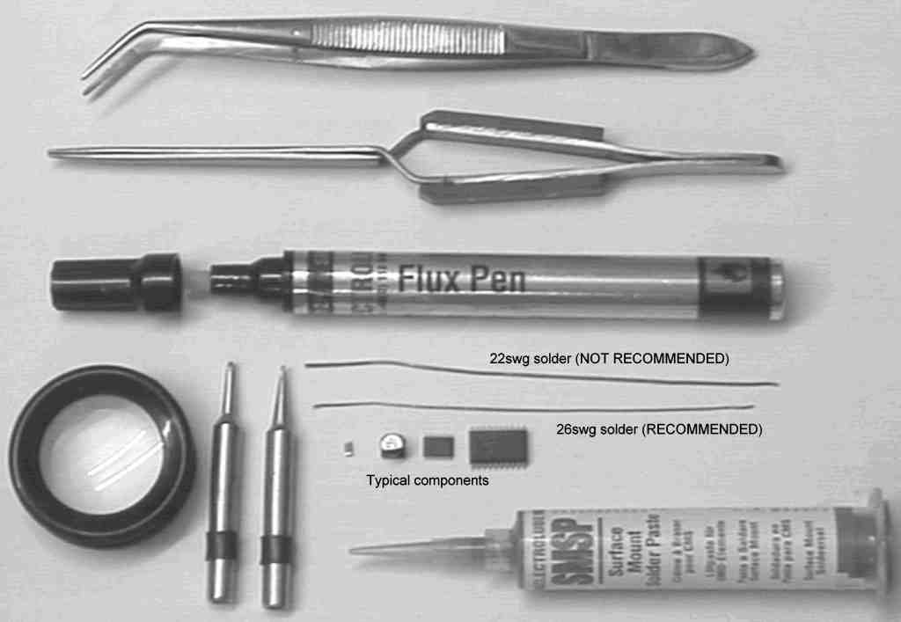

Controller construction

Start by confirming the identity of all the components and their position on the board using the overlay and diagrams.

Decide how you are going to mount both the keyboard and display, there are several choices;
- Mounted directly above the controller board using spacers with nuts & bolts, and wired either directly to the board using ribbon cable or you can use 0.1” / 2.54mm pitch pins / sockets.
- Mount them on the case and use ribbon cable back to the board, in which case I would suggest that no more than 8” or 200mm of cable be used.

Once you are sure of all the positions, then start construction with the 16 x 5k6 pull-up resistors R13 to R28. Follow these with the two PCA9544 devices, these are the smallest SMD in the kit so once they are fitted then the rest is normal construction!

The PIC chip is supplied ready programmed and with a socket, this is so that the chip can be easily extracted and replaced if the software needs to be updated at any time.

There will not normally be connections made to the ICP (In-Circuit Programming) connector, which is located just above and to the right of the PIC chip on the board. This is only a provision for future possibilities.

The connectors on the right hand side of the board can either be soldered to directly or 0.1” / 2.54mm pitch plugs and sockets used.

The multiplexed I2C bus connections are the 16 holes to the left of the 16 SM pull-up resistors, see the overlay printed on the next page. These will be used from the bottom (next to R13) upwards in pairs (SDA/SCL-1, SDA/SCL-2, etc.) to connect to the switching matrix boards, more on this later when the matrix boards are built. These can also use connectors if you wish, however ribbon cable is a more efficient method.

The LCD’s contrast / viewing angle, can be adjusted by changing the resistor R5, if required once the board has been built tested and installed in its final case. Other than this there are no adjustments, links or options on the board.

Once the board has been fully built, check carefully that all components are correctly oriented and that there are no obvious faults. Check carefully with a magnifying glass that U5/6 are both correctly oriented and that there are no shorts between legs. If all is OK then testing of the board can begin.
Controller board Testing

As there are no options or links to worry about, if the board does not work first time then it is really only dry joints or solder bridges that need to be considered.

The PIC processor carries out a number of tests of its own during the power up period, and will display the results as a string of hexadecimal characters. However before the display is initialised the following actions take place, don’t worry too much about some of the terms below, if you are familiar with the PIC processors then it will help you debug any problems, but there is a check list later if things don’t work;

- Serial interface port is initialised, the baud rate is set to 19200bps and the XON code will be sent.
- Port A is initialised for the LCD control lines. Port B is initialised for the primary I2C bus and for the Sounder. Port C is initialised for the Keypad and the LCD data lines.
- The I2C routines are started and the clocking speed (100KHz) setup.
- The LCD display is initialised as having two lines of 16 characters and cleared.
- The display is sent “The MATRIX v1.00” on the top line.
- A tone is sent to the Sounder for 255mS to indicate that the basic controller is functioning.
- The PIC now starts to check the I2C bus for connected devices and displays the counts on the second line in Hex. The first check is to see if the controller has been configured or if a re-configuration is required;
FF=Never configured before, 01=Previously configured, 00=Reconfigure requested.
- The next count confirms that the processor is expecting to see a Keypad, LCD display, 2 lines of display and a serial port. This is displayed as ‘0F’.
- Checks for CMOS memory present, the count indicates how many 256Byte blocks are present, this should display as ‘08’.
- The number of PCF8574’s or PCF8574A I/O chips fitted, for the controller board on its own this should display as ‘01’.
- The number of PCA9544, I2C Multiplexor chips fitted, for the controller board on its own this should display as ‘02’.
- Next is the count of TDA8540 switching chips, for the controller on its own this will of course be zero ‘00’, however when the switching boards are fitted then the count will increase.
- A further Beep is sounded at this point to indicate that the configuration checks have been completed. A final tally is shown indicating which if any of the above counts have changed from their previous values.
T | h | e |  | M | A | T | R | I | X |  | v | 1 | . | 0 | 0
F | F | 0 | F | 0 | 8 | 0 | 1 | 0 | 2 | 0 | 0 | 1 | F
- The display will remain on screen for 4 seconds before either entering normal operation indicated by a ‘OK>’ on the top line or following a series of short beeps asking if you wish to re-configure the board.

If all works perfectly first time, then you will hear a double beep, followed by a 4 second pause whilst the numbers above are shown, followed by 4 short beeps and the display will ask if you want to re-configure.
R | e | c | o | n | f | i | g | u | r | e | ? | ?
 | F | = | Y | e | s |  | E | = | N | o

If after applying +12V to the unit the above has not happened then follow the procedure below to identify the most likely faults. If it all works switch off, give yourself a pat on the back and progress to building the switching boards.
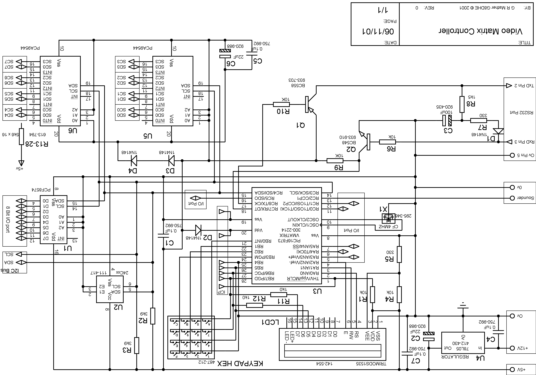
 | Capacitors | IC’s | Transistors |  | Misc.
1 | 0.1uF | PCF8574(A) | BC558 |  | D1-D4 1N4148
2 | 22uF | M24C16-BN6 | BC548 |  | X1 Ceramic Resonator 4MHz
3 | 100uf | PIC16F873 |  |  | LCD1 TRIMODS1535 Display
4 | 0.1uf | LM78L05ACZ |  |  | Hex Keyboard
5 | 0.1uf | PCA9544 |  |  | Piezo Sounder
6 | 22uf | PCA9544 |  |  | 28 pin 0.3” DIL socket
7 | 0.1uf |  |  |  | Matrix controller PCB

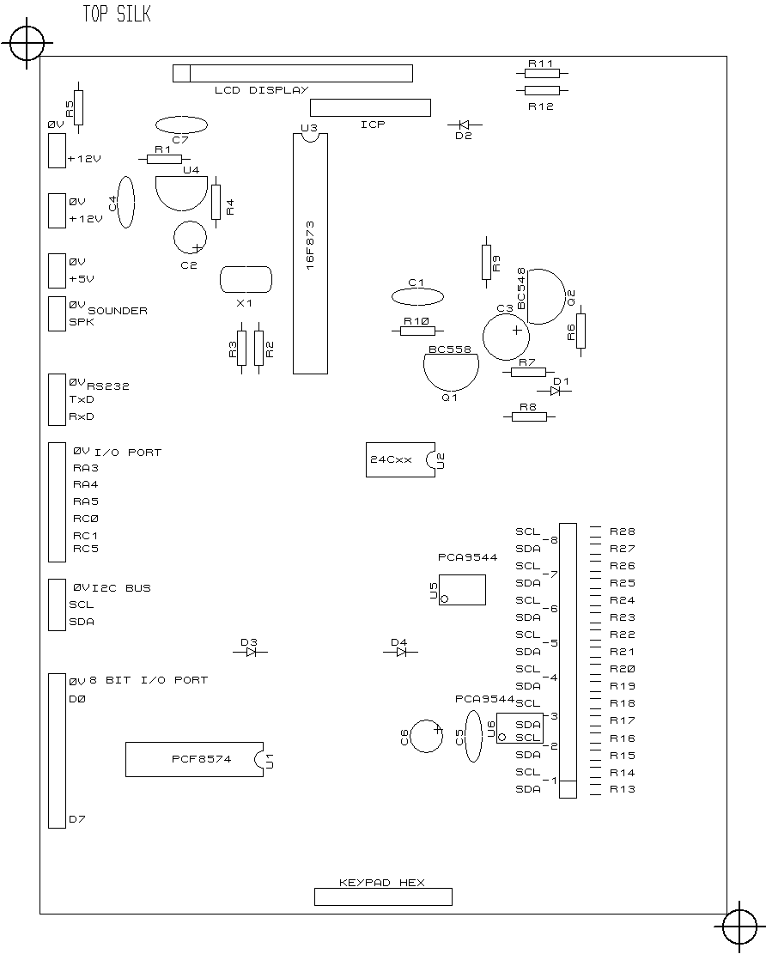
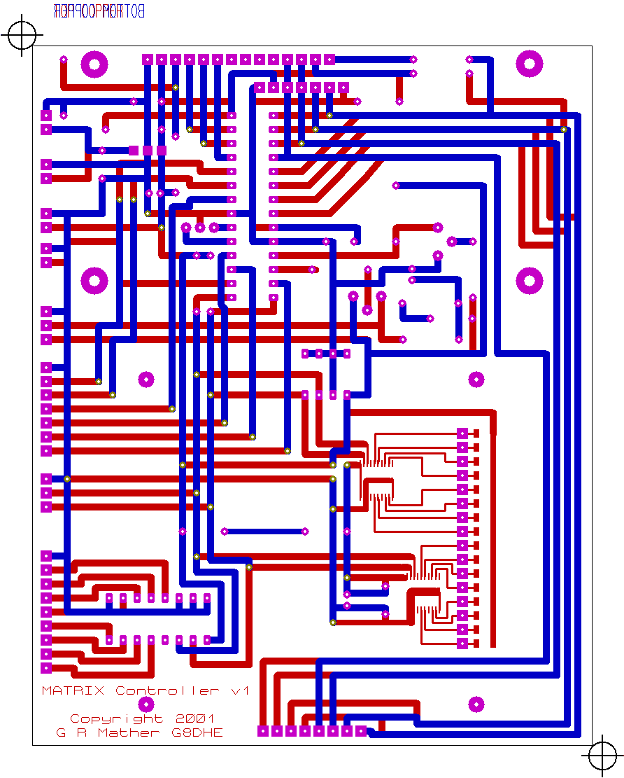
 | Resistors
1 | 10k
2 | 3k9
3 | 3k9
4 | 10k
5 | 330
6 | 10k
7 | 330
8 | 1k5
9 | 10k
10 | 10k
11 | 1k0
12 | 1k0
13-28 | 5k6 SMD

Controller board fault finding

- If after applying +12v to the controller board nothing happens at all then;
- Check that the +5Volt line is being generated
2. If only the top line of the display appears to get a “background”;
- Double check that the +5v line is correct, and that there are no excessive currents being drawn. An I2C line being held high by a short will cause high currents to be drawn.
- Check that the 4MHz oscillator in the PIC is running, by checking with either a Rx tuned to 4MHz or watching with a scope on Pin 10 where a 1.0-1.2volt 4MHz sine wave should be visible.
- Check that the display control and data lines are correctly connected.
- Both lines of the display appear to get a “background” but no text appears;
- Check that the primary I2C lines are both pulled high to +5V on R2 and R3 also check the levels at the connector on the edge of the board.
- The text “The MATRIX v1.00” appears, but there is no noise from the sounder;
- Check that the sounder is connected; makes a small click when connected to +5V and earth (disconnect to test this!!).
- Check with a scope or other high impedance device that a square wave appears on Pin13 of the PIC in the audio range about 1.5KHz.
- Only the first 4 characters ‘FF0F’ or similar appear on the lower line of the display;
- The primary I2C bus has an error on it, one or both of the lines are pulled low, shorted together or are not being pulled low by the PIC for some reason – inspect the board for errors and shorts.
- Only the first 10 characters ‘FF0F080102’ or similar appear on the lower line of the display;
- A secondary (multiplexed) bus has an error on it, one or both of the lines are pulled low, shorted together or are not being pulled low by the PIC for some reason – inspect the board for errors and shorts. To find which bus is causing the problem run a meter along the I2C lines, the pair of lines that have at least one line low is the one causing the problem.
- An incorrect count of devices on the I2C bus appears (see the process above for the counts that are expected to appear) i.e. ‘FF0F08010200xx’ does not appear;
- The relevant chips are not responding to the I2C bus commands, check that the signals SCL & SDA are appearing on the correct pins of each chip, this is best checked with a scope.
- If the counts appear correctly but it doesn’t progress further, then look for an intermittent fault or a time / heat problem.
- A strange symbol appears after reaching the command prompt line;
- This is caused by stray noise during the power up sequence on the serial input – you can safely ignore it as after starting a command with the A on the keypad the character will be ignored anyway.

Switch board construction

Start by confirming the size and layout of each of the switching planes you intend to build. Whilst the boards come as a standard 16x16 size they can be cut down (if size is important) or built up in multiples of 4x4 from, the minimum size of a 4x4 up to nearly 60x60! The size of each plane does NOT have to be square either, 8x12 or 24x16 are perfectly acceptable. Different planes can be different sizes and it is also possible to fit more than a single plane on to a single board, two 8x8 planes can be built on one 16x16 board if you wish. Attached at the end are some layout templates to assist in planing your layouts.

There are two examples showing completed sheets. Start by numbering the 4x4 switches from 0, following the red arrows (2 wire links for I2C busses) between columns / boards / planes. Once the position of each switch is known then the address number of each switch can be completed. Starting at 0, number each switch up to a max. of 6 (0 to 6 = 7 actual switches) then start again at 0, repeat until each address is completed. Finally complete the I2C bus numbers, these start from 1 and increment each time the address starts again at 0. Draw a thick line between 4x4 switches when the I2C bus changes, within a column, the thick line represents a CUT of the I2C bus lines on the underside of the board, between the pairs of un-drilled connectors – WARNING only two lines SCL & SDA need to be cut, not all the lines!!! The diagrams preceding the templates indicate clearly where the cuts should be made and also where the address “links” will be in relation to a cut. Finally mark the +8V regulators and terminating resistors that need to be fitted for each column / row on each board.

Now that you have the boards defined confirm the identity of all the components and their position on the board using the overlay and diagrams for your size of board.

The next step is to make the cuts in the tracks as indicated in the section “Switch board configuration”, follow this by mounting all the SMD. Fit the wire ended components and then make the address links. Finally complete the I2C bus links between columns so that each I2C bus has seven devices (other than the final one possibly), these are effectively the red arrows on the template. Do note that the links do not have to go from top to bottom, they can just as easily connect at the top or bottom of the columns depending on where the cuts have been made. Double check everything and then repeat for the other switching boards as required, remember to extend the final I2C bus between boards to the start of the next board.

If you are happy with the results then wire the +12V power lines up. Using ribbon cable, about 12- 18 inches / 300-400mm in length, prepare the I2C bus lines from the switching boards but don’t connect them at the controller end just yet.

Power up the boards and check that each regulator is giving the expected voltage to its column. If all is OK then power down. Now connect the first I2C bus pair at the controller end, power up and the controller should report during its checking stage that ‘07’ TDA8540 devices have appeared;
T | h | e |  | M | A | T | R | I | X |  | v | 1 | . | 0 | 0
F | F | 0 | F | 0 | 8 | 0 | 1 | 0 | 2 | 0 | 7 | 1 | F
If no display appears then check the I2C lines for shorts. If an incorrect count appears then check the address links for the devices on bus 1, also make sure that all the devices on bus 1 are correctly powered, by checking both ground (Pins 9 & 20) and + rails (Pins 4, 13 & 15) to the chips themselves.

When the correct count appears then proceed on to the second I2C bus by connecting it to the controller. The new count should be ‘0E’ (14 in Hexadecimal), keep repeating until all the busses are connected for your configuration – if your not sure of your counting in hexadecimal there is a table later in this manual.
Now continue with the Fault Finding and Test section of this document.
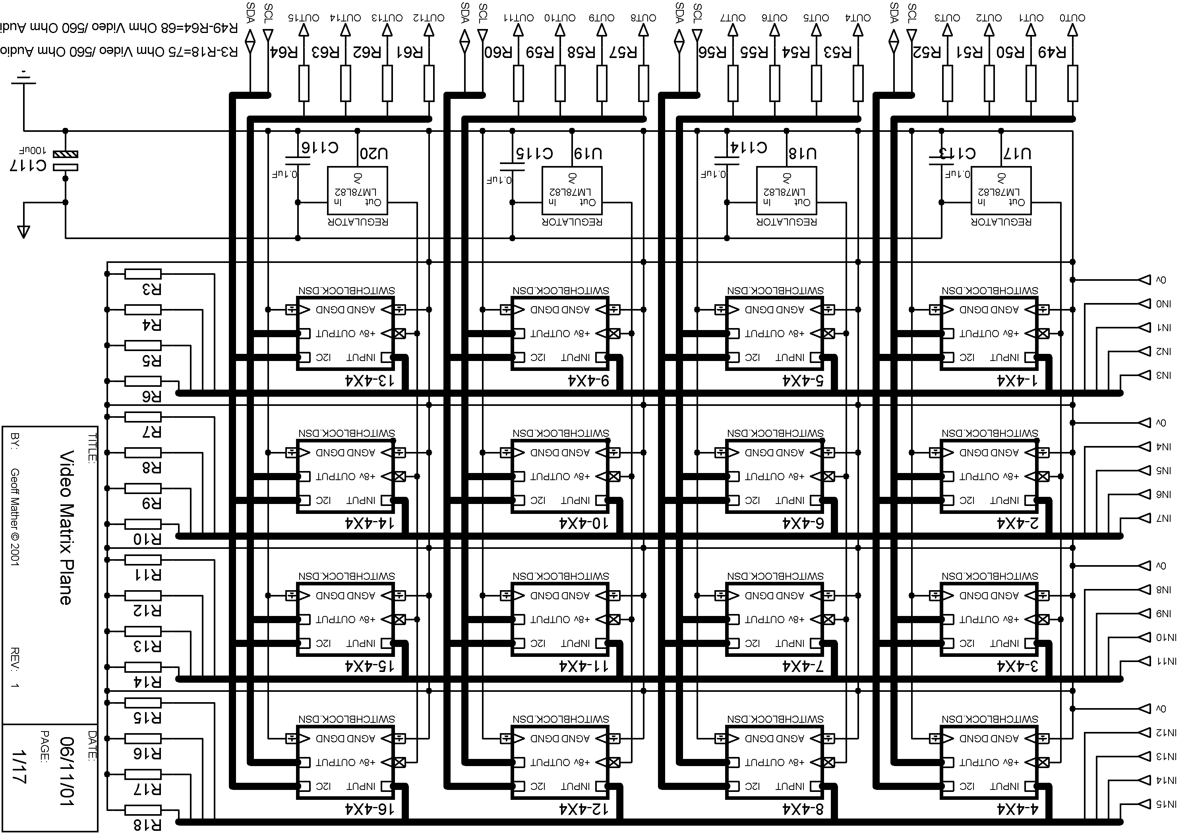

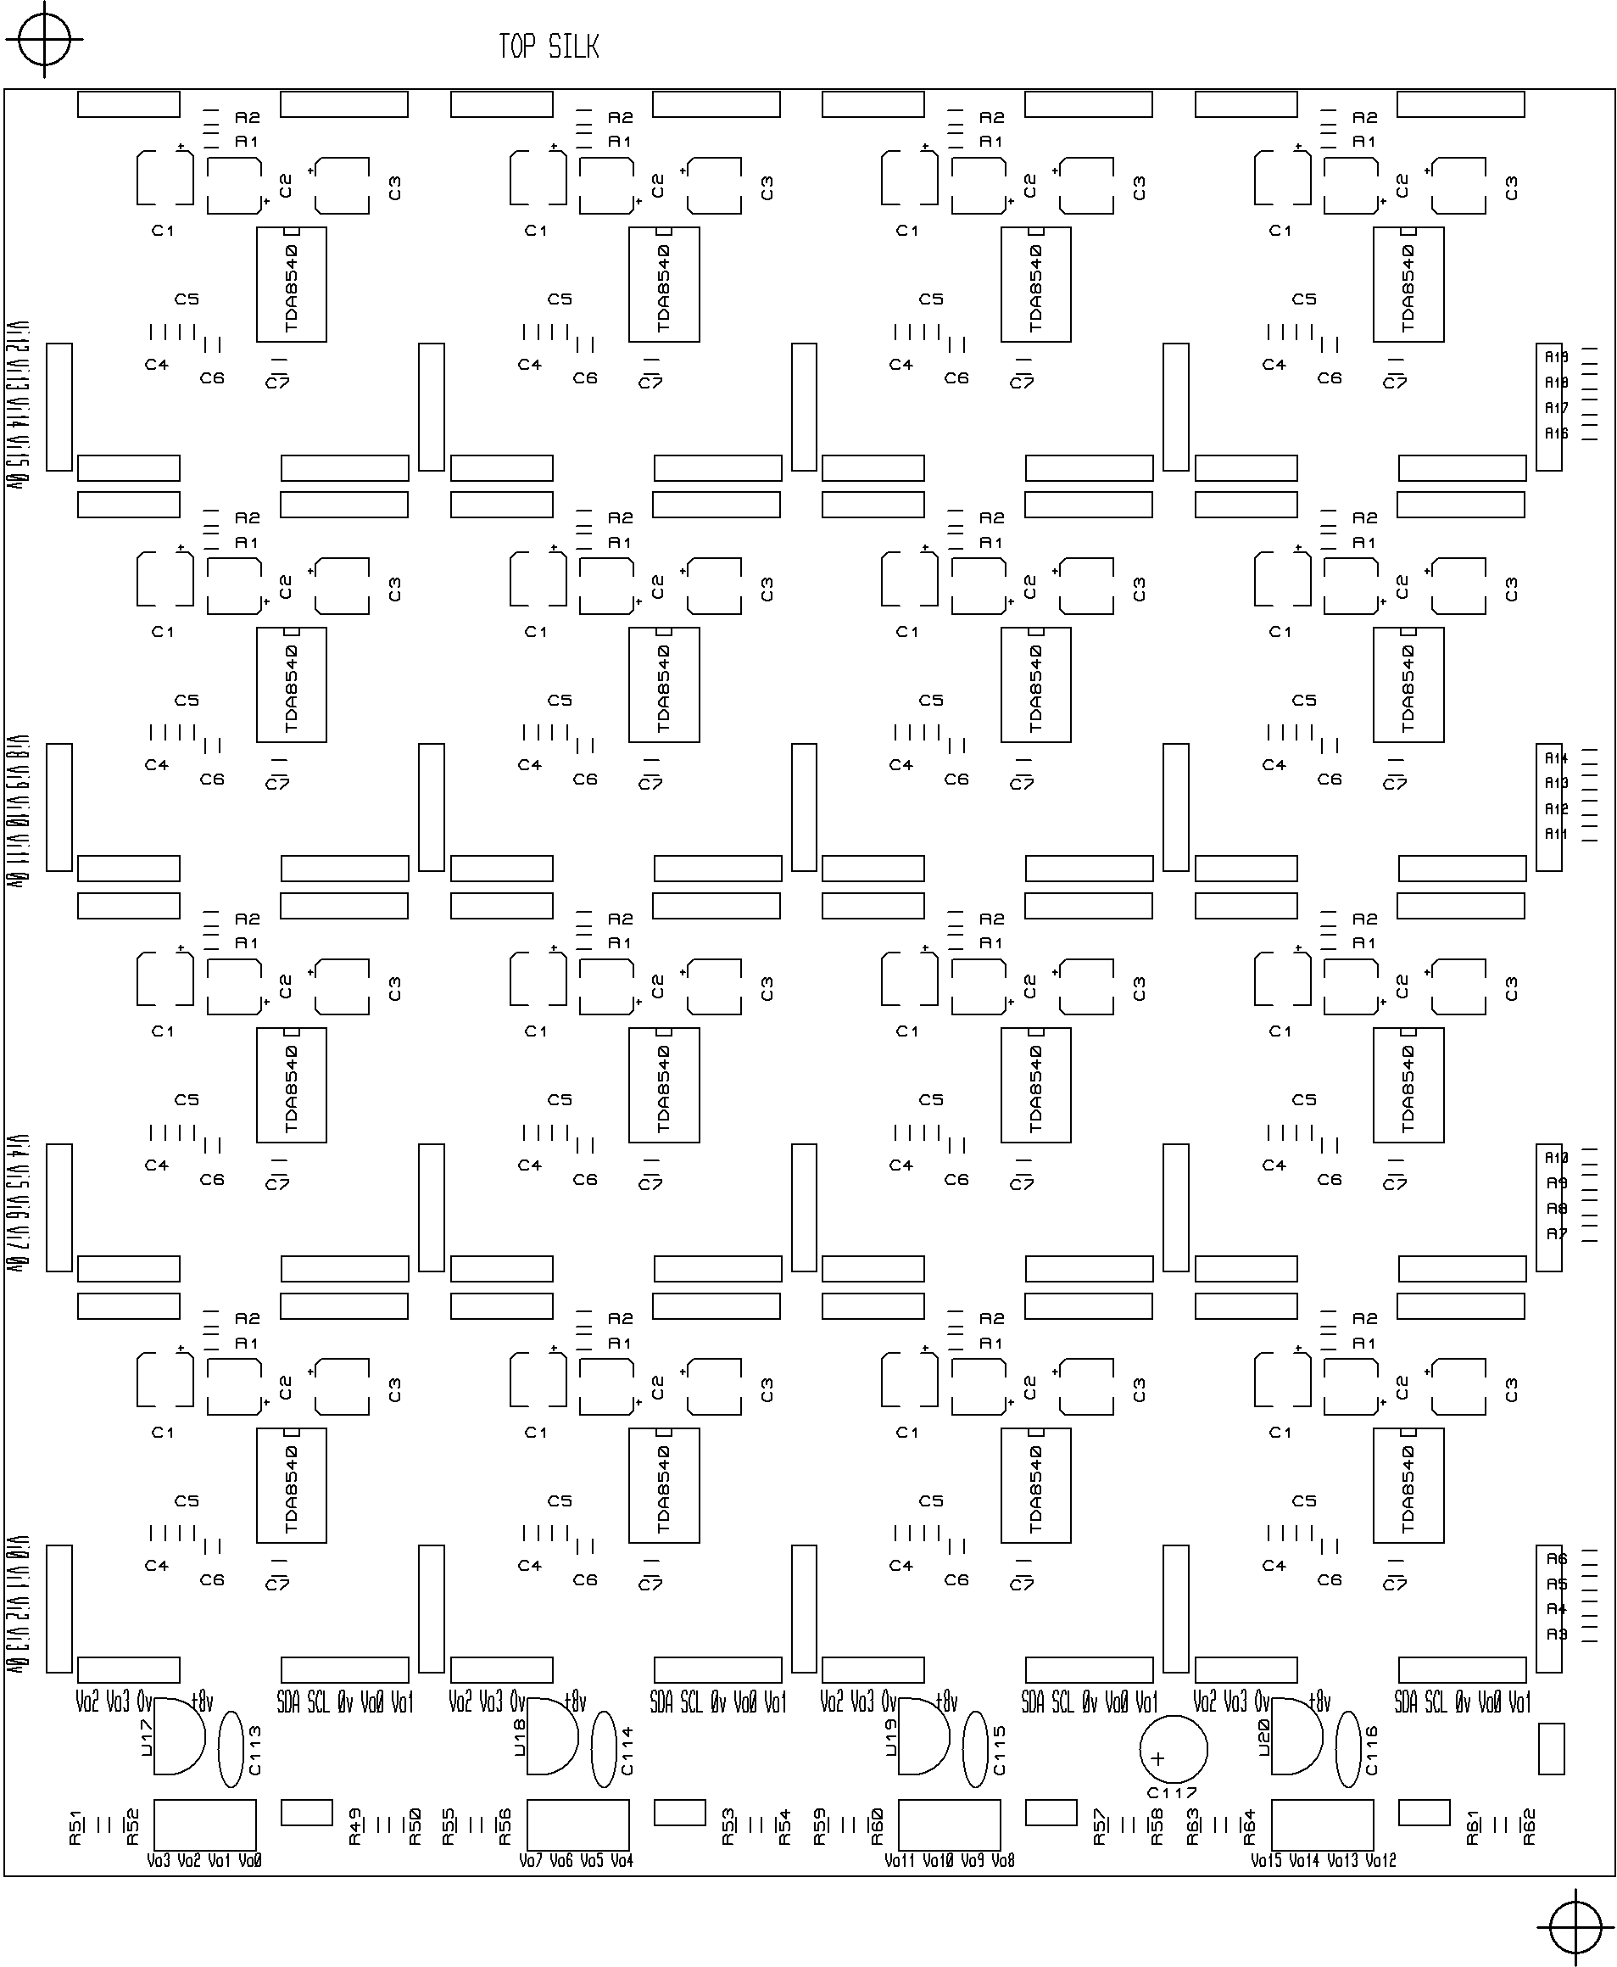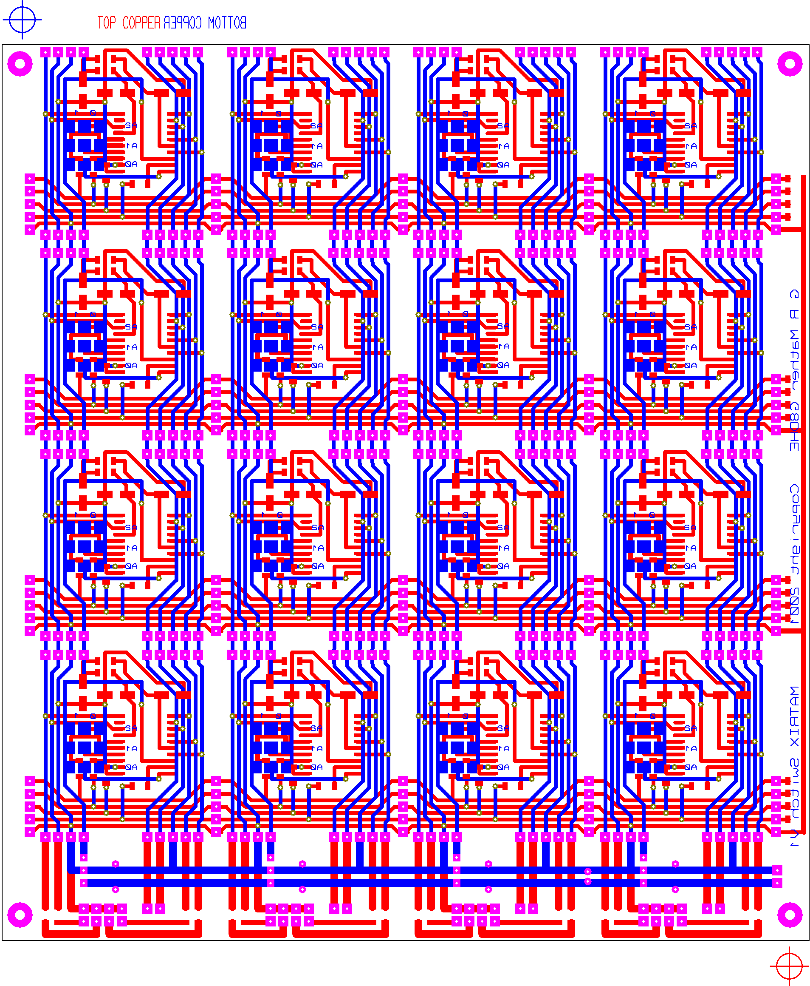
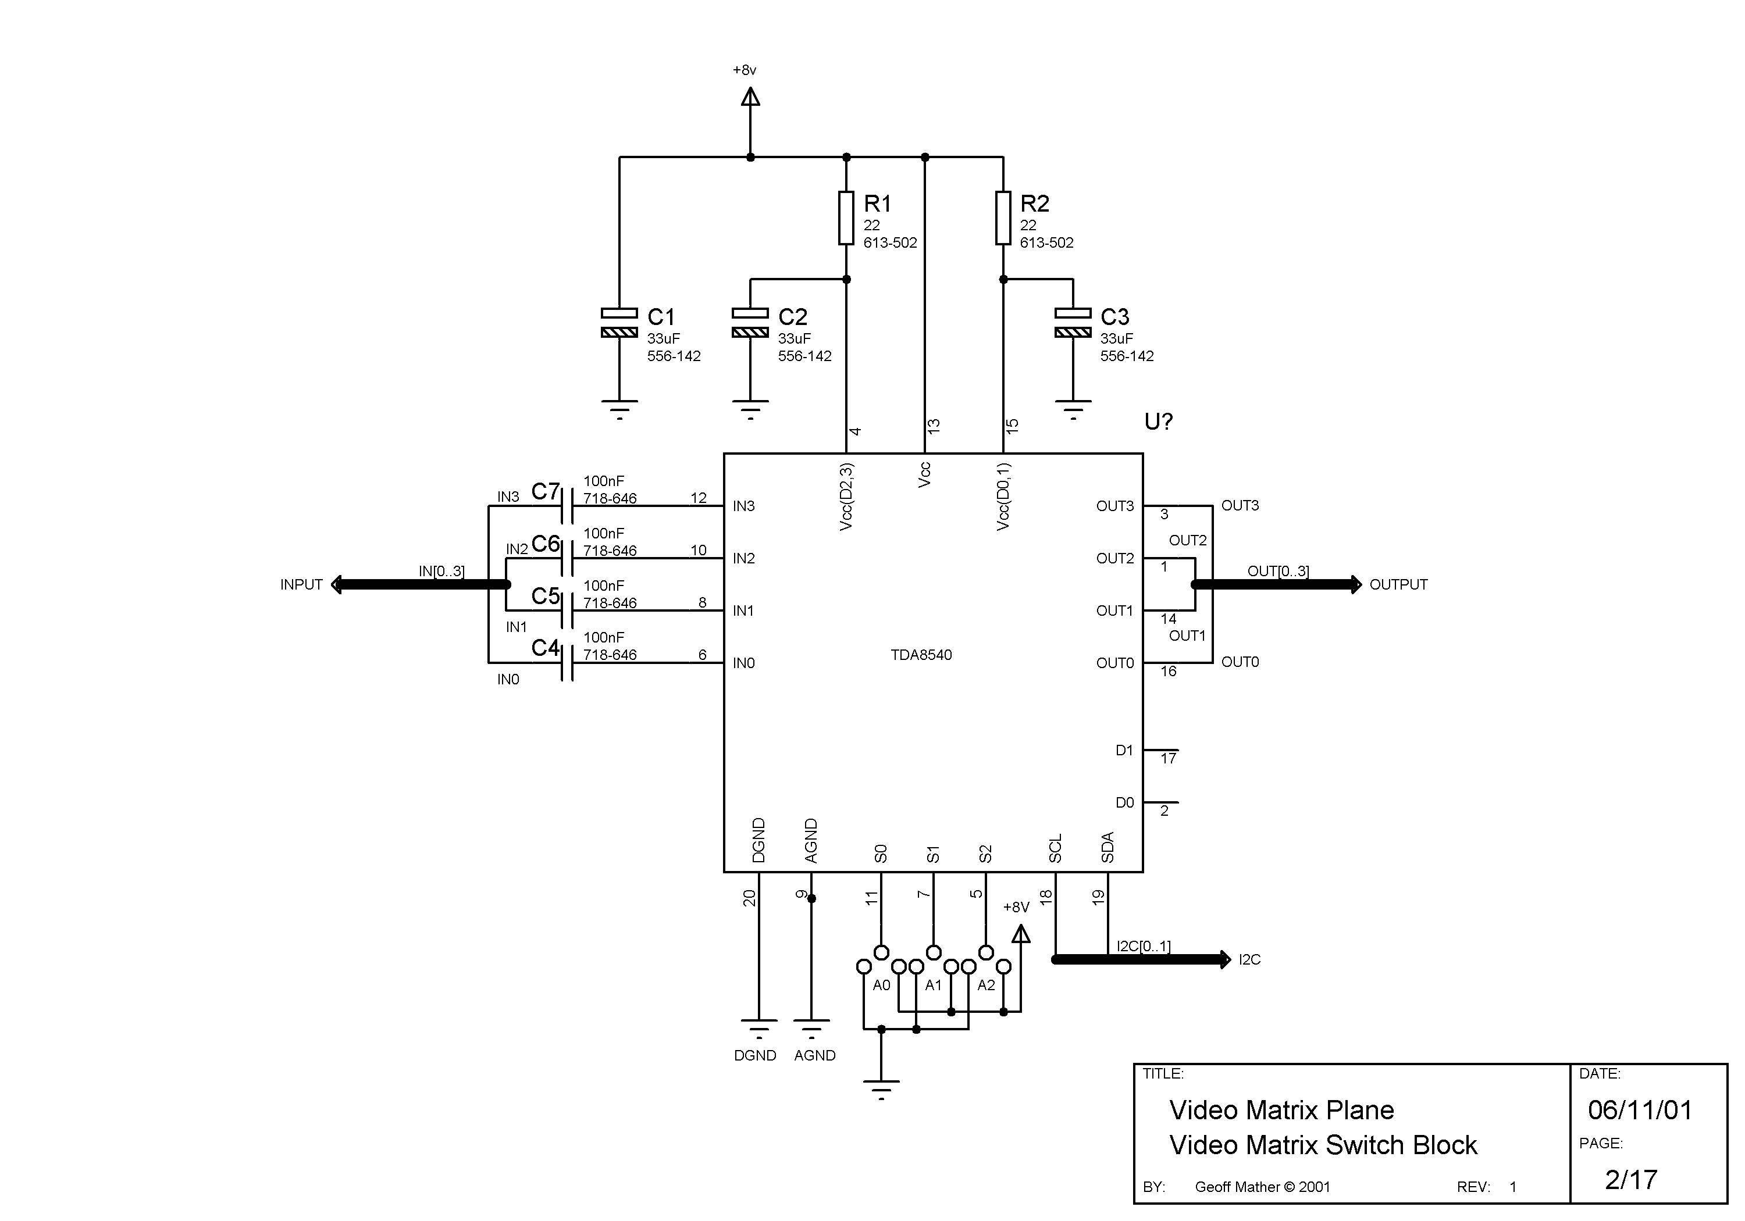
 | Capacitors | Resistors | IC
1 | 33uF | 22 | TDA8540
2 | 33uF | 22
3 | 33uF
4 | 0.1uF
5 | 0.1uF | x4 for 8x8 or x16 for 16x16
6 | 0.1uF
7 | 0.1uF

 | Capacitors |  |  | Resistors  Video | Audio |  |  | IC
113 | 0.1uF |  | 3 - 18 | 75 | 560 |  | 17-20 | LM78L82
114 | 0.1uF |  | 49 - 64 | 68 | 560
115 | 0.1uF
116 | 0.1uF
117 | 100uF

Decimal to Hexadecimal conversion table
Those numbers highlighted in Red are those that will appear on the display count as each new I2C bus is connected, other than for the last bus which will most likely have less than 7 devices connected to it.
Tens | 00 | 10 | 20 | 30 | 40 | 50 | 60 | 70 | 80 | 90
Units
0 | 00 | 0A | 14 | 1E | 28 | 32 | 3C | 46 | 50 | 5A
1 | 01 | 0B | 15 | 1F | 29 | 33 | 3D | 47 | 51 | 5B
2 | 02 | 0C | 16 | 20 | 2A | 34 | 3E | 48 | 52 | 5C
3 | 03 | 0D | 17 | 21 | 2B | 35 | 3F | 49 | 53 | 5D
4 | 04 | 0E | 18 | 22 | 2C | 36 | 40 | 4A | 54 | 5E
5 | 05 | 0F | 19 | 23 | 2D | 37 | 41 | 4B | 55 | 5F
6 | 06 | 10 | 1A | 24 | 2E | 38 | 42 | 4C | 56 | 60
7 | 07 | 11 | 1B | 25 | 2F | 39 | 43 | 4D | 57 | 61
8 | 08 | 12 | 1C | 26 | 30 | 3A | 44 | 4E | 58 | 62
9 | 09 | 13 | 1D | 27 | 31 | 3B | 45 | 4F | 59 | 63
Switch board – Configuration

The switch boards have to be physically configured before they can be used. This involves cutting some lines (traces) and making some solder links to set up each 4x4 switches address. The track cutting is best carried out before any components are fitted, and the solder links are best carried out after all the components have been fitted.

Before any cutting or linking is carried out use the board template sheet to draw up your own particular configuration. Start by numbering the 4x4 switches from 0, following the red arrows between columns / boards / planes. Once the position of each switch is known then the address number of each switch can be completed. Starting at 0, number each switch up to a max. of 6 (0 > 6 = 7 actual switches) then start again at 0, repeat until each address is completed. Finally complete the I2C bus number, these start from 1 and increment each time the address starts again at 0. Draw a thick line between 4x4 switches when the I2C bus changes, within a column, the thick line represents a CUT of the I2C bus lines on the underside of the board, between the pairs of un-drilled connectors – WARNING only two lines SCL & SDA need to be cut, not all the lines!!!

Make sure that you have numbered every switch block that you intend to fit. That the addresses have been calculated, that the I2C bus numbers have been filled in and that the changes between I2C bus numbers are indicated. Having done that check it again!! Its really annoying to spot the error after just having cut a track. However the board has been designed to make it easy to re-configure hence the only points that need to be cut also have a couple of drilled holes either side for a link to be inserted if required. Below are some diagrams to assist by showing where to cut and also which pads to link for each address.

One word of warning the templates are drawn looking down on the board from the FRONT side, so when it comes to cutting and linking then do remember to mirror image the positions, because your now looking from the UNDERSIDE of the board!

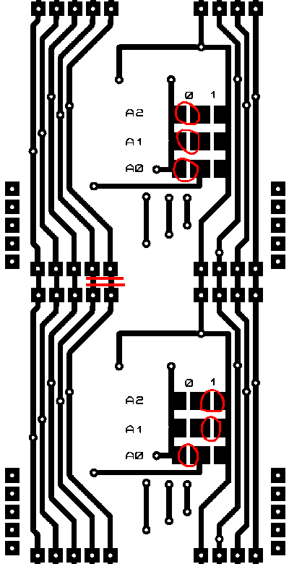
Where to cut the I2C Bus lines; The tracks will always be cut between two blocks in the same column where the address changes from a 6 to a 0. The picture left shows this from the underside view.

The address pads need to be linked in the following fashion;
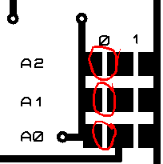
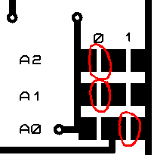
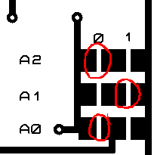
Address = 0 Address = 1 Address = 2

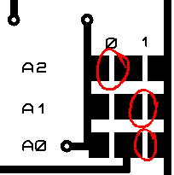
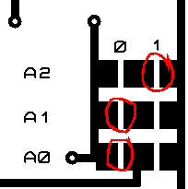
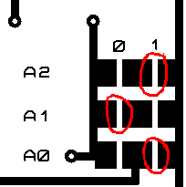
Address = 3 Address = 4 Address = 5

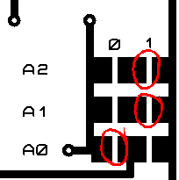
Address = 6

Plane = Video | Audio
Switch =  Address =  I2C Bus = | Switch =  Address =  I2C Bus = |  | Switch =  Address =  I2C Bus = |  | Switch =  Address =  I2C Bus = |  | 4xR 75 / 560
Switch =  Address =  I2C Bus = | Switch =  Address =  I2C Bus = |  | Switch =  Address =  I2C Bus = |  | Switch =  Address =  I2C Bus = |  | 4xR 75 / 560
Switch =  Address =  I2C Bus = | Switch =  Address =  I2C Bus = |  | Switch =  Address =  I2C Bus = |  | Switch =  Address =  I2C Bus = |  | 4xR 75 / 560
Switch =  Address =  I2C Bus = | Switch =  Address =  I2C Bus = |  | Switch =  Address =  I2C Bus = |  | Switch =  Address =  I2C Bus = |  | 4xR 75 / 560
Reg |  | Reg |  | Reg |  | Reg | +12 Volt
4xR 68 / 560 |  | 4xR 68 / 560 |  | 4xR 68 / 560 |  | 4xR 68 / 560 | +12 Volt

Plane = Video | Audio
Switch =  Address =  I2C Bus = | Switch =  Address =  I2C Bus = |  | Switch =  Address =  I2C Bus = |  | Switch =  Address =  I2C Bus = |  | 4xR 75 / 560
Switch =  Address =  I2C Bus = | Switch =  Address =  I2C Bus = |  | Switch =  Address =  I2C Bus = |  | Switch =  Address =  I2C Bus = |  | 4xR 75 / 560
Switch =  Address =  I2C Bus = | Switch =  Address =  I2C Bus = |  | Switch =  Address =  I2C Bus = |  | Switch =  Address =  I2C Bus = |  | 4xR 75 / 560
Switch =  Address =  I2C Bus = | Switch =  Address =  I2C Bus = |  | Switch =  Address =  I2C Bus = |  | Switch =  Address =  I2C Bus = |  | 4xR 75 / 560
Reg |  | Reg |  | Reg |  | Reg | +12 Volt
4xR 68 / 560 |  | 4xR 68 / 560 |  | 4xR 68 / 560 |  | 4xR 68 / 560 | +12 Volt

Plane = Video | Audio
Switch =  Address =  I2C Bus = | Switch =  Address =  I2C Bus = |  | Switch =  Address =  I2C Bus = |  | Switch =  Address =  I2C Bus = |  | 4xR 75 / 560
Switch =  Address =  I2C Bus = | Switch =  Address =  I2C Bus = |  | Switch =  Address =  I2C Bus = |  | Switch =  Address =  I2C Bus = |  | 4xR 75 / 560
Switch =  Address =  I2C Bus = | Switch =  Address =  I2C Bus = |  | Switch =  Address =  I2C Bus = |  | Switch =  Address =  I2C Bus = |  | 4xR 75 / 560
Switch =  Address =  I2C Bus = | Switch =  Address =  I2C Bus = |  | Switch =  Address =  I2C Bus = |  | Switch =  Address =  I2C Bus = |  | 4xR 75 / 560
Reg |  | Reg |  | Reg |  | Reg | +12 Volt
4xR 68 / 560 |  | 4xR 68 / 560 |  | 4xR 68 / 560 |  | 4xR 68 / 560 | +12 Volt

Plane = Video | Audio
Switch =  Address =  I2C Bus = | Switch =  Address =  I2C Bus = |  | Switch =  Address =  I2C Bus = |  | Switch =  Address =  I2C Bus = |  | 4xR 75 / 560
Switch =  Address =  I2C Bus = | Switch =  Address =  I2C Bus = |  | Switch =  Address =  I2C Bus = |  | Switch =  Address =  I2C Bus = |  | 4xR 75 / 560
Switch =  Address =  I2C Bus = | Switch =  Address =  I2C Bus = |  | Switch =  Address =  I2C Bus = |  | Switch =  Address =  I2C Bus = |  | 4xR 75 / 560
Switch =  Address =  I2C Bus = | Switch =  Address =  I2C Bus = |  | Switch =  Address =  I2C Bus = |  | Switch =  Address =  I2C Bus = |  | 4xR 75 / 560
Reg |  | Reg |  | Reg |  | Reg | +12 Volt
4xR 68 / 560 |  | 4xR 68 / 560 |  | 4xR 68 / 560 |  | 4xR 68 / 560 | +12 Volt

Example: 8x8 Video + Stereo on two boards
Plane = 0 Video | Audio
Switch =  Address =  I2C Bus = | Switch =  Address =  I2C Bus = |  | Switch =  Address =  I2C Bus = |  | Switch =  Address =  I2C Bus = |  | 4xR 75 / 560
Switch =  Address =  I2C Bus = | Switch =  Address =  I2C Bus = |  | Switch =  Address =  I2C Bus = |  | Switch =  Address =  I2C Bus = |  | 4xR 75 / 560
Switch =1  Address =1  I2C Bus =1 | Switch =3  Address =3  I2C Bus =1 |  | Switch =  Address =  I2C Bus = |  | Switch =  Address =  I2C Bus = |  | 4xR 75 / 560
Switch =0  Start  Start  Address =0  I2C Bus =1 | Switch =2  Address =2  I2C Bus =1 |  | Switch =  Address =  I2C Bus = |  | Switch =  Address =  I2C Bus = |  | 4xR 75 / 560
Reg |  | Reg |  | Reg |  | Reg | +12Volt
4xR 68 / 560 |  | 4xR 68 / 560 |  | 4xR 68 / 560 |  | 4xR 68 / 560 | +12Volt

Example: 16x16 Video + Mono
Plane = 0 Video | Audio
Switch =3  Address =3  I2C Bus =1 | Switch =7  Address =0  I2C Bus =2 |  | Switch =11  Address =4  I2C Bus =2 |  | Switch =15  Address =1  I2C Bus =3 |  | 4xR 75 / 560
Switch =2  Address =2  I2C Bus =1 | Switch =6  Address =6  I2C Bus =1 |  | Switch =10  Address =3  I2C Bus =2 |  | Switch =14  Address =0  I2C Bus =3 |  | 4xR 75 / 560
Switch =1  Address =1  I2C Bus =1 | Switch =5  Address =5  I2C Bus =1 |  | Switch =9  Address =2  I2C Bus =2 |  | Switch =13  Address =6  I2C Bus =2 |  | 4xR 75 / 560
Switch =0  Address =0  I2C Bus =1 | Switch =4  Address =4  I2C Bus =1 |  | Switch =8  Address =1  I2C Bus =2 |  | Switch =12  Address =5  I2C Bus =2 |  | 4xR 75 / 560
Reg |  | Reg |  | Reg |  | Reg | +12Volt
4xR 68 / 560 |  | 4xR 68 / 560 |  | 4xR 68 / 560 |  | 4xR 68 / 560 | +12Volt

Plane =1 & 2 Video | Audio
Switch =  Address =  I2C Bus = | Switch =  Address =  I2C Bus = |  | Switch =9  Address =2  I2C Bus =2 |  | Switch =11  Address =4  I2C Bus =2 |  | 4xR 75 / 560
Switch =  Address =  I2C Bus = | Switch =  Address =  I2C Bus = |  | Switch =8  Address =1  I2C Bus =2 |  | Switch =10  Address =3  I2C Bus =2 |  | 4xR 75 / 560
Switch =5  Address =5  I2C Bus =1 | Switch =7  Address =0  I2C Bus =2 |  | Switch =  Address =  I2C Bus = |  | Switch =  Address =  I2C Bus = |  | 4xR 75 / 560
Switch =4  Address =4  I2C Bus =1 | Switch =6  Address =6  I2C Bus =1 |  | Switch =  Address =  I2C Bus = |  | Switch =  Address =  I2C Bus = |  | 4xR 75 / 560
Reg |  | Reg |  | Reg |  | Reg | +12 Volt
4xR 68 / 560 |  | 4xR 68 / 560 |  | 4xR 68 / 560 |  | 4xR 68 / 560 | +12 Volt

Plane = 1 Video | Audio
Switch =19  Address =5  I2C Bus =3 | Switch =23  Address =2  I2C Bus =4 |  | Switch =27  Address =6  I2C Bus =4 |  | Switch =31  Address =3  I2C Bus =5 |  |  | 4xR 75 / 560
Switch =18  Address =4  I2C Bus =3 | Switch =22  Address =1  I2C Bus =4 |  | Switch =26  Address =5  I2C Bus =4 |  | Switch =30  Address =2  I2C Bus =5 |  |  | 4xR 75 / 560
Switch =17  Address =3  I2C Bus =3 | Switch =21  Address =0  I2C Bus =4 |  | Switch =25  Address =4  I2C Bus =4 |  | Switch =29  Address =1  I2C Bus =5 |  |  | 4xR 75 / 560
Switch =16  Address =2  I2C Bus =3 | Switch =20  Address =6  I2C Bus =3 |  | Switch =24  Address =3  I2C Bus =4 |  | Switch =28  Address =0  I2C Bus =5 |  |  | 4xR 75 / 560
Reg |  | Reg |  | Reg |  | Reg | +12 Volt
4xR 68 / 560 |  | 4xR 68 / 560 |  | 4xR 68 / 560 |  | 4xR 68 / 560

Switch board fault finding & testing

Before connecting a board up it is STRONGLY recommended that you first check for shorts and bridges between the many bus lines that run in parallel across the board. It is very easy for small solder bridges to occur. Carry out a visual inspection but then follow this with a check using a meter or small electronic buzzer.

- Power up the board and check each +8 volt rail, if the voltage is around;
+3 volts, then suspect that one of the 22 Ohm resistors is bridging to earth on the low voltage side. Check which one using a meter.
0 Volts, suspect that either a 22 Ohm resistor is bridging to earth on its high side, or
an address programming link is bridging across all three pads, or
a solder bridge between the parallel bus lines carrying the +8 Volt and earth lines.

- When connecting each I2C bus in turn to the controller, the chip count does not increase by the expected number (+7 for all but the last bus). The controller stops checking on finding a fault, so if the count does not increment at all then;
The bus itself is faulty with a bridge or short to earth,
The first chip is failing to respond, check the address first, then check continuity between the PCB lines and the chip leg itself. Check that all 3 supply rails are actually present on the chip legs, check that the 0v lines to the chip are also correct by measuring the voltage on the chip leg itself.
If the count does increment but not by the expected number then count up and look at the NEXT chip in address order for faults.

- Once all the chips on a board are correctly visible to the digital side of the system then it is well worth checking for correct analogue operation. This is best accomplished by connecting each input in turn to each output. Use can be made of the “Set All” command this connects a given input on a plane to all of the outputs on a plane, it is then simply a case of injecting a signal and checking for the correct level of output. Rather than trying to fault find on a problem by problem basis, experience has shown that it is best to check ALL input / output combinations first and then many faults will identify themselves as any single fault will affect several outputs / inputs together. Begin by drawing up a simple grid chart showing input and output numbers (note the numbering pattern in the example below as it helps when testing and wiring up later!!) and a cell which can be used to indicate if a crosspoint is not working correctly. Use the command F p ii 1 E (see User manual for full details) where p is the plane number starting at ZERO, and ii is the input number to be tested i.e. First F0031E, then F0021E, F0011E, F0001E, F0071E etc. The command will connect the input on the plane to all of the outputs at the same time, then inject a suitable signal (an audio signal generator is fine for this test) and check that it appears at each output at the correct level. Indicate on the chart FAULTS by placing a cross in the relevant cell. After checking the entire plane then the patterns (see over) and likely faults can be diagnosed. It is best to work on a single plane at a time when doing this testing.

Check soldering of output pin on TDA8540.
X

Check input capacitor and / or input pin of TDA8540.
X

Check analogue supply rail to TDA8540, pins 4 and / or 15.
X

Check ground pins 9 & 20 and supply pins to TDA8540 pins 4, 15 & 13.
X

Check soldering of output terminating resistor or for a short on output side track.
X

12 |  |  |  |  | X | X |  |  |  |  | X
13 |  |  |  |  | X | X |  |  |  |  | X
14 |  |  |  |  | X | X |  |  |  |  | X
15 |  |  |  |  | X | X |  |  |  |  | X
08 |  |  |  |  |  |  |  |  |  |  | X
09 |  |  |  |  |  |  |  |  |  |  | X
10 | X | X | X | X |  |  |  |  |  |  | X
11 |  |  |  |  |  |  |  |  |  |  | X
04 |  |  |  |  |  |  |  |  |  |  | X |  | X | X | X | X
05 |  |  |  |  |  |  |  |  |  |  | X |  | X | X | X | X
06 |  |  |  |  |  |  |  |  |  |  | X |  | X | X | X | X
07 |  | X |  |  |  |  |  |  |  |  | X |  | X | X | X | X
00 |  |  |  |  |  |  |  |  |  |  | X
01 |  |  |  |  |  |  |  |  |  |  | X
02 |  |  |  |  |  |  |  |  |  |  | X
03 |  |  |  |  |  |  |  |  |  |  | X
 | 03 | 02 | 01 | 00 | 07 | 06 | 05 | 04 | 11 | 10 | 09 | 08 | 15 | 14 | 13 | 12

I
n
p
u
t
s
Outputs

Configuring the MATRIX

The software provided in the PIC carries out a check during power up of what devices are connected to its I2C bus. It uses this data along with some information that you will key in shortly to configure the switches and other hardware into a working system. At the end of the process it stores all this information and during subsequent power ups it checks the data to make sure that nothing has changed since it was last used. In this way if you add additional hardware the software can ask you to re-configure it, also should a fault develop then there will be a warning and information on what has changed! Note if a hardware change occurs then a warning message asking you to acknowledge the change by pressing the “F” key will appear, if this happens and no planned change has been made then you have a fault, so say No (B) to Reconfigure ?? then you can start fault finding without losing the previous configuration.

T | h | e |  | M | A | T | R | I | X |  | v | 1 | . | 0 | 0
F | F | 0 | F | 0 | 8 | 0 | 1 | 0 | 2 | 0 | 7 | 1 | F
FF=Never configured Changes indicator
01=Previously configured
00=Reconfiguration requested
Requires Keypad Count of TDA8540
Serial port & LCD display chips fitted
Count of CMOS memory Count of PCA9544
in 256Byte blocks chips fitted
Count of PCF8574(A)
chips fitted

After a change or the first time the MATRIX has been powered up then 4 seconds after the above has been displayed then the following question will be posed;
R | e | c | o | n | f | i | g | u | r | e | ? | ?
 | F | = | Y | e | s |  |  | E | = | N | o
The answer will be YES in this case – F.

Respond with an F, as we do need to tell it the configuration.
All acceptable answers will result in a rising double beep, unacceptable answers a falling double beep.
Next question is;
P | l | a | n | e | = | 0 |  | E | n | t | e | r |  | #
o | f |  | I | P | ‘ | s | = | ? | ?
You are being asked to enter the number of Inputs that Plane 0 has, this should always be entered as a two digit number i.e. ‘08’ or ‘16’. It will also need to be a multiple of 4, otherwise a beep and the question will re-appear. If you make an error and spot it then press B and any other digit.
P | l | a | n | e | = | 0 |  | E | n | t | e | r |  | #
o | f |  | O | P | ‘ | s | = | ? | ?
OK, you guessed it now the number of OP’s for Plane 0, again a two digit answer.

These two questions will now repeat, but for Plane 1, then Plane 2 etc until all the 4x4 switch elements have been accounted for. If you make a mistake with one of the numbers and didn’t spot it then either you will be told;
T | o | o |  | b | i | g |  | ! | !
o | f |  | I | P | ‘ | s | = | 0 | 8

And after a few seconds you will be sent back to Plane 0 to start again.
Or if you get asked the question for more Planes than you expected, then somewhere along the line you answered with too small a number and hence it believes there is yet another Plane to be defined. In this case just put a large number in ‘88’ for example and then you will be sent back to Plane 0 to start again.

When you have all the Plane information in correctly, then you will be greeted with a set of bleeps to signify that the planes are completed.

At this point there is an option offered if there has been more than a single Plane defined, this is to allow the creation of a ganged group of Planes that, using certain commands, will operate together for more information on grouping refer to the MATRIX User Guide;
G | r | o | u | p |  | P | l | a | n | e | s |  | ?
 | F | = | Y | e | s |  |  | E | = | N | o
If you wish to take this option then answer Yes otherwise No, in which case skip the following section and continue with the Input and Output lines.

G | r | o | u | p |  | P | l | a | n | e | = | 0
 | F | = | Y | e | s |  |  | E | = | N | o
You can now answer Yes or No to each Plane that has been previously defined, if you answer Yes then that Plane will be added to the grouped planes. Answering No will leave that Plane out of the group. During testing it is suggested that you do not group planes, once testing is complete then the option to reconfigure can be taken which will then allow you to group the desired planes. When the last Plane number has been dealt with then again a set of bleeps will be sounded to indicate the end of this section.

So on to the Input and Output lines, with the next stage;
I | O |  | C | h | a | n | n | e | l | = | 0 |  | B | 0
t | y | p | e |  | 1 | = | I | P |  | 0 | = | O | P |  | ?
Due to the size of the display the question is a bit terse, but you are being asked to define the 8 IO lines as either Inputs (1) or Outputs (0) for the Channel 0 (this is the PCF8574(A) chip on the controller board itself, additional chips up to a max. of eight can be fitted on an extension board to give 64 control lines). If you don’t intend to use the control lines then make them Inputs by typing in a ‘1’. The question will then repeat for bit 1 (b1) and so on up to bit 7, eight lines in all.

Once completed then yet another set of bleeps to signify completion and the message;
S | a | v | i | n | g |  | d | a | t | a
0 | 7
With a fairly rapid count is displayed whilst the information is stored within the flash memory within the PIC chip where the data is stored.

After the data is safely stored then the board will restart, this time after the initial checks have been made you should be given the command prompt;
O | K | >

